**=**

A project report on

**Gen-N Web Store**

Submitted in partial fulfillment of the requirement for

The award of the degree

MASTER OF COMPUTER APPLICATIONS

OF

Gujarat Technological University

(GTU)

**Pratik Ranpara**

**145583693030**

**Chauhan Divyeshkumar B.**

**145223693075**

**Project Guide**

Kartik Trivedi



Marwadi Education Foundation’s Group of Institutions

(MEFGI)

Rajkot, Gujarat.

2015 – 2016

**DECLARATION**

We **Pratik Ranpara** & **Chauhan Divyeshkumar B.** hereby declare that this project work entitled **Gen-N Web Store** is a record done by us.

Here we have used maximum facilities of H.T.M.L., P.H.P., JavaScript and My S.Q.L to make this web-site more easy and perfect. This web-site is completely modulated and implemented in top-down approach, using SDLC (Software Developer Life Cycle) which includes…

* Analysis ✓
* Designing ✓
* Coding ✓
* Testing ✓
* Documentation ✓
* Implementation

We have used our maximum knowledge to make this website maximum practically in use.

Place:

Date:

Pratik Ranpara

**ACKNOWLEDGEMENT**

It was highly eventful session at the MCA (Masters of Computer Applications), Marwadi Educational Foundation Group of Institutes, working with highly devoted computer teacher’s community and probably remains the most memorable experience. Hence this Acknowledgment is a humble attempt to thank all those who were directly or indirectly involved in our Project Work and were of immense help us to successfully complete this project.

We greatly thank **Mr. Kartik Trivedi** for giving us this opportunity and support for developing the system.

We are also thankful to all the professors whose inspiration, guidance and generous support gave us sufficient strength to prepare the project.

This acknowledgment is lifeless without expressing our heart-felt gratitude to our **parents** & **friends** for being a constant source of inspiration & uncountable reasons. This project is a small tribute to their hopes & aspirations.

Pratik Ranpara

Divyesh Chauhan

**CONTENTS**

|  |  |  |
| --- | --- | --- |
| **Chapters** | **Particulars** | **Page No.** |
| **1** | **SYNOPSIS** | 5 |
| **2** | **INTRODUCTION**   * Project Profile * Project Description * Benefits of System * Goals of System | 6 |
| **3** | **TECHNICAL DESCRIPTION**   * Hardware Specification * Software Specification | 12 |
| **4** | **OPERATING ENVIRONMENT**   * P.H.P * Java Script * H.T.M.L * My SQL | 14 |
| **5** | **FEASIBILITY STUDY**   * Technical Feasibility * Economic Feasibility * Operational Feasibility | 21 |
| **6** | **SYSTEM DESIGN AND DEVELOPMENT**   * Data Flow Diagram * Use Case Diagram * Table Structure * Database Design | 23 |
| **7** | **TESTING**   * Unit Testing * Integration Testing * White Box Testing * System Testing * Environment Testing | 37 |
| **8** | **SCREEN SHOTS** | 46 |
| **9** | **SOURCE CODE** | 62 |
| **10** | **CONCLUSION** | 77 |
| **11** | **BIBLIOGRAPHY** | 78 |

**SYNOPSIS**

In today’s modern, sophisticated and fast world, online classifieds have become a medium of communication among the internet users. On one end it is informative and on the other end it is convenient and cost effective. Online classifieds are most effective and proved market winner in current vast competitive business era. No one can ignore such a powerful medium in totally changed market environment.

Gen-N Web-Store is available to serve as your online marketplace, which gives following benefits:

* It offer simple solutions to your classified advertising needs allowing you to post electronic products classifieds.
* Promote your electronic product, company or service to a vast audience
* Build consideration, awareness, and buyer response
* Customize ads to fit individual or company needs
* Convenient and easy to use

***Introduction***

* Project Profile
* Project Description
* Benefits of System
* Goals of the System

**PROJECT PROFILE**

|  |  |
| --- | --- |
| **Project Title:** | Gen-N Web-Store |
| **Front-end Tool:** | P.H.P |
| **Back-end Tool:** | My SQL |
| **Other Tool** | JavaScript, C.S.S, H.T.M.L |
| **Project guide:** | Mr. Kartik Trivedi |
| **Team Size:** | 2 |
| **Project Duration:** | 6 Months. |
| **Submitted By:** | Chauhan Divyeshkumar B.  Pratik Ranpara |
| **Submitted To:** | Gujarat Technological University (GTU) |

**PROJECT DESCRIPTION**

Gen-N Web-Store website provides different categorized classifieds/ads. It also allow user to upload their ads.

Gen-N Web-Store allows two types of registration:

* User registration

User can get own account id to interact with Companies, Administrator.

* Company registration

Companies can register themselves as Companies who can upload advertisements and launch electronic products.

There are three major section of online classified portal.

* User section
* Company section
* Admin section
* **User Section:**
* In this section, user can view categorized electronic product classifieds.
* User can search particular classified.
* User can update their personal profile and password.
* User can give a reviews for the site or classified products.
* **Company Section:**
* In this section Companies can freely upload their electronic product classifieds.
* Companies can update their personal profile and password.
* Companies can upload and manage different electronic product classifieds.
* Companies can receive reviews from user and able to give response too.
* **Admin Section:**
* Admin can manage different database entries.
* Admin can view the information related to registered users, companies with their classified product’s details.
* Admin can add and update home page slider.
  + Admin can add and remove categories of classifieds.
  + Admin can view and delete mails received by registered users or companies.

BENEFITS OF THE SYSTEM

* By using this system customers will be able to to post their electronic products classifieds.
* Problems may be solved.
* It is fully web based system.
* Easy maintenance of volume of data.
* No delay in any retrieving procedure.
* Lesser manpower and manual work.

GOAL OF THE

SYSTEM

* To maintain users to add any kind of electronic products classified records with the help of “My SQL”.
* Add product classified online and maintain full process also.
* To maintain records of users and companies.
* Give information of registered users and companies and their classifieds to administrators.

**TECHNICAL DESCRIPTION**

* Software Specification
* Hardware Specification

Listed below are the minimum system requirements for installing and operating the proposed system.

**SOFTWARE SPECIFICATION**

* Operating System: Windows XP/7/8/10
* Xampp (Apache Server & My SQL)
* Browser (Internet Explorer, Google Chrome, Mozilla Firefox)

**HARDWARE DESCRIPTION**

* 1.70A-GHz or higher processor
* Display Device with Minimum 1200 X 800 Resolutions.
* 512 MB of RAM
* 1 GB of available disk space

***OPERATING ENVIRONMENT***

* P.H.P
* Java Script
* H.T.M.L
* My SQL

**P.H.P**

* **Introduction of php**
* The full form of PHP is “Hyper-text preprocessor”. Its original name was “Personal Home Page”.
* Resume Leadoff Software engineer, Apache team member is the creator and original driving force behind PHP. The first part of PHP was developed for his personal use in late 1994.
* By the middle of 1997, PHP was being used on approximately PHP is 50,000 sites worldwide.
* PHP is server side scripting language, which can be embedded in HTML or used as a stand-alone.
* PHP doesn’t do anything about what a page looks and sounds like. In fact, most of what PHP does is invisible to the end user.
* Sometimes looking at a PHP page was not necessarily be able to tell that it was not written purely in HTML, because usually the result is HTML.
* PHP is an official model of apache HTTP server.
* PHP is fully cross-platform, meaning it runs native on several flavors of UNIX, as well as on Windows and now on Mac OS x.
* **Advantages of php**
* Cost**:**

PHP costs you nothing. It is open source software and doesn’t need to purchase it for development.

* Ease **of use:**

PHP is easy to learn, compared to the others. A lot of ready made PHP scripts are freely available in market so, you can use them in your project or get some help from them.

* HTML **-** Support**:**

PHP is embedded within HTML, In other words PHP pages are ordinary HTML pages that escape into PHP mode only when necessary. When a client requests this page the web server preprocesses it.

* Cross**-**Platform Capability**:**

MySQL run native on every popular flavor of Unix and Windows. A huge percentage PHP and of the world’s HTTP servers run on one of these two classes of OS

* Stability**:**
  + The server doesn’t need to be rebooted often.
  + The software doesn’t change radically and incompatibly from release to release.
  + To our advantage, both of these apply to both MySQL and PHP.
* Speed**:**

PHP is pleasingly zippy in its execution, especially when compiled as and Apache module on the Unix side. Although it takes a slight performance hit by being interpreted rather than compiled, this is far outweighed by the benefits PHP drivers from its status as a Web server module.

**JAVA SCRIPT**

* **What is JavaScript?**
  + JavaScript was designed to add interactivity it HTML pages.
  + JavaScript is a scripting language (a scripting language is a lightweight programming language).
  + A JavaScript consists of lines of executable computer code.
  + A JavaScript is usually embedded directly into HTML pages.
  + JavaScript is an interpreted language (means that scripts execute without preliminary complication).
  + Everyone can use JavaScript without purchasing a license.
* **Are Java and JavaScript same?**
  + No! Java and JavaScript are to completely different language in both concept and design.
  + Java (Developed by Sun Microsystems) is a powerful and much more complex programming language in the same category as C and C++.
* **What can JavaScript do?**
* **JavaScript gives HTML designers a programming tool**

Html authors are normally not programmers but JavaScript is a scripting language with a very simple syntax. All most any one can put a small “Snippets” of code into their HTML pages.

* **JavaScript can put dynamic text into HTML pages ~**

A JavaScript statement like this: document. Write (“<h1>” + name + “</h1>”) can write a variable text into a HTML page.

* **JavaScript can react to events ~**

Set to execute when something happens like when a page has finished loading or when a user clicks on HTML elements.

* **JavaScript can read and write HTML elements ~**

A JavaScript can read and change the content of an HTML element.

* **JavaScript can be used to validate data ~**

JavaScript can be used to validate from data before it is submitted to a server, this will save the server from extra processing.

* **JavaScript can be used to delete the visitor’s browser**

JavaScript can be used to delete the visitor’s browser, and –depending on the browser load another pages specifically a design for that browser.

**H.T.M.L**

* Tim Berners-Lee originated HTML.
* HTML developed a few years ago as a subset of SGML (Standard generalized markup language), which is a higher-level markup language that has long been a favorite of the department of defense.
* Any HTML document is also valid for SGML.
* HTML is a hypertext markup language that is used to develop web pages.
* HTML is not a programming language Like C, C++ and a JAVA.
* It is a cross platform markup language that is design to be flexible enough to display text and other elements Like Graphical on a variety of views.
* The HTML documents consists of a special tags that are embedded in an ASCII document
* Web browser like Internet Explorer, Netscape navigator etc, Interprets these tags.

**My SQL**

* MYSQL, the most popular open source SQL database management system, is developed, distributed, and supported by MYSQLAB.
* MYSQLAB is a commercial company, founded by the MYSQL developers. It is second-generation open source company that unities open source values and methodology with a successful business model.
* The MYSQL web site (“http://www.MySQL.com/”) provides the latest information about the MYSQL software and MYSQLAB.
* The official way to pronounce “MYSQL” is “MY ESS QUE ELL” (not “my sequel”), but we don’t mind if you pronounce if as “my sequel” or in some other localized way.
* **Feature of MYSQL**
* MySQL is a Database Management System.
* MySQL is a relational Database Management System.
* MySQL software is Open Source.
* The MySQL Database server is very fast, reliable, and easy to use.
* MySQL server works in client/server or embedded system environment.
* A large amount of contributed MySQL software is Available.

***Feasibility***

***Study***

* Technical Feasibility
* Economic Feasibility
* Operational Feasibility

Feasibility of a project determines whether it is possible to develop the project. There are three main factors, which determine the feasibility of the project.

**Technical Feasibility**

The technical feasibility takes into consideration the technical requirements and their availability in the market. It determines whether it is possible to develop the proposed system with the present technologies available.

**Economic Feasibility**

The economic feasibility takes into consideration the financial matters regarding the proposed system. The organization measures the cost effectiveness of the proposed system.

**Operation Feasibility**

The operation feasibility deals with the matter whether the proposed system fulfills the requirement of the firm. This feasibility determines whether the proposed system covers all the aspects of the current system.

***SYSTEM DESIGNING AND DEVELOPMENT***

* Data Flow Diagram
* Use Case Diagram
* Database Design
* Table Structure

**DATA FLOW**

**DIAGRAM**

Guest

User

Registered

User/

Registered

Company

0

GEN-N

Web-Store

Admin

Sign Up

Sign Up

Successful

Sign In

View/Add

Products

Sign In

Update System

**Context Diagram**

Registered

User

Username/

password

Signin

Failure

1.1

Sign

In

User

Request

Username/

password

Get

Username/

password

1.2

View/

Update

User Profile

View

Profile

Get

User Details

Update

Details

1.3

View

Products

Products

View

Products

Get

Products

Request

Products

Contact

Admin

1.4

Mail

Admin

Contact

Send

Mail

Request

User Details

Fetch

User Details

1.5

Categorized

Products

View

Categorized

Products

Category

1.6

View

Product

Company

Details

Request

Products

Details

Fetch

Products

Details

Company

Request

CompanyDetails

Fetch

CompanyDetails

Reviews

1.7

View

Add

Review

Review

Get

Review

Add

Review

**Registered User Level 1 Data Flow Diagram**

Admin

User

Admin

Fetch

Company Details

Request

CompanyDetails

Products

By

Company

Contact

Send

Mail

2.4

Mail

Admin

Contact

Admin

Get

Company Details

Get

CompanyDetails

Update

Details

2.2

View/

Update

Company Profile

Get

Username/

password

Request

Username/

password

Company

Request

Company

Product

View

Profile

Add

Products

2.1

Sign

In

Username/

password

Get

Categorize

Signin

Failure

Category

Fetch

Company

Product

2.3

Add

Products

Add

Product

Details

Products

1.5

View

Company

Products

**Company Level 1 Data Flow Diagram**

Admin

Username/

password

Signin

Failure

1.1

Sign

In

Admin

Request

Username/

password

Get

Username/

password

1.2

View/

Delete

User

Company

Manage

User

Company

1.3

View

Delete

Products

Products

Manage

Products

Get

Products

Delete

Products

1.4

View

Delete

Mails

Contact

1.5

Add

Delete

Category

Category

**Admin Level 1 Data Flow Diagram**

Company

User

Get/Delete

User

Get/Delete

Company

Get/Delete

Category

Manage

Mails

Get/Delete

Mails

Manage

Slider

1.5

Add

Delete

Slider

Slider

Get/Delete

Slider

**Use Case Diagram**

* **Guest User side use-case diagram**

**Registration**

**View Gen-N Information**

**View   
 Classifieds/Ads**

* **User side use-case diagram**

**Login**

**View**

**Classifieds**

**View**

**Details**

**Update Personal Details**

**Search**

**Classifieds**

**Feedback**

* **Advertiser side use-case diagram**

**Login**

**View Inquiry Box**

**Update Personal Details**

**My Account**

**Upload & Manage Classifieds**

**Feedback**

* **Admin side use-case diagram**

**Update Sliders**

**Manage User**

**Update**

**Category**

**Manage**

**Products**

**Manage**

**Company**

**Manage**

**Mails**

**TABLE STRUCTURE**

**Admin**

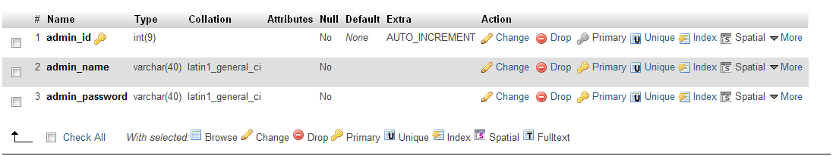

**User**

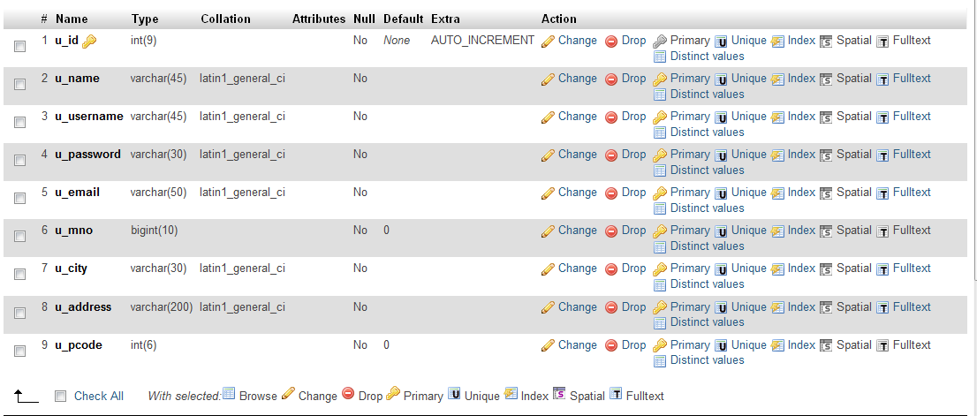

**Company**

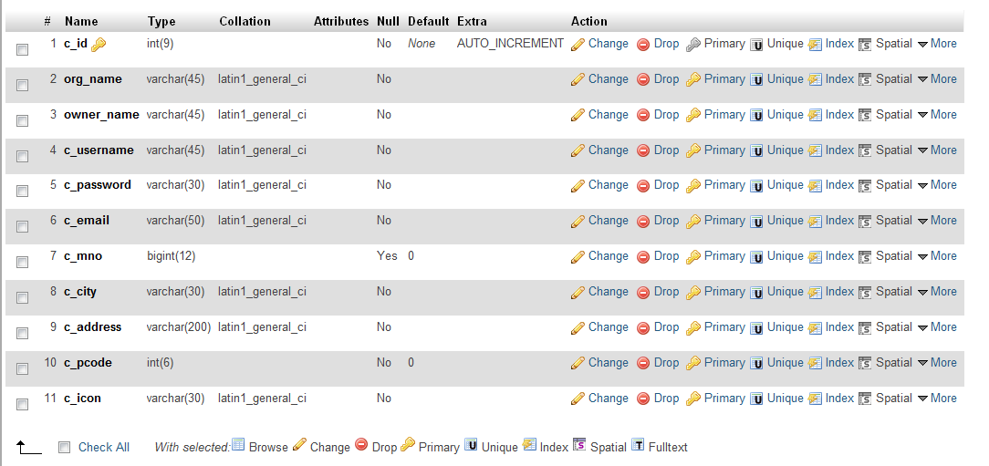

**Product**

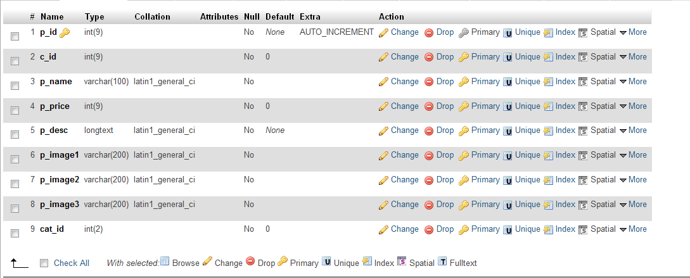

**Category**

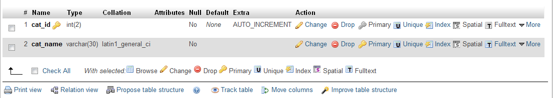

**Slider**

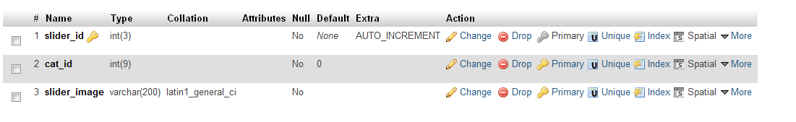

**Contact**

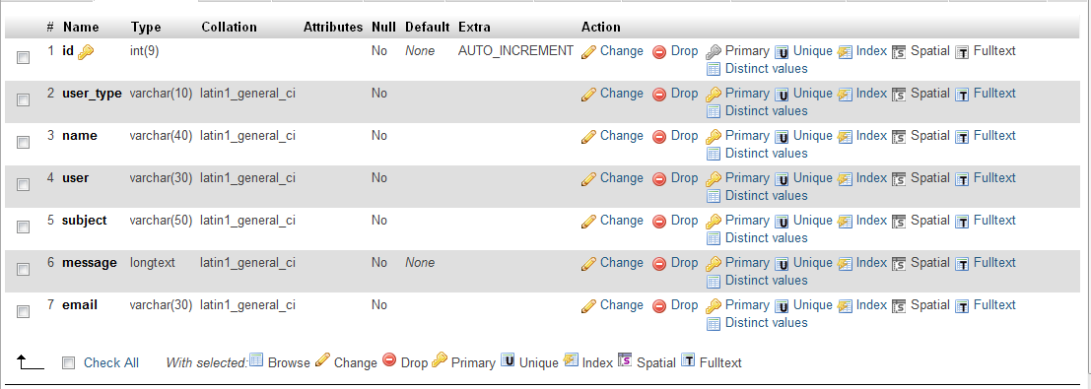

**Review**

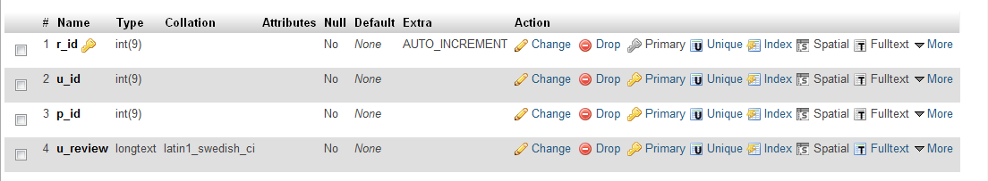

**DATABASE**

**DESIGN**

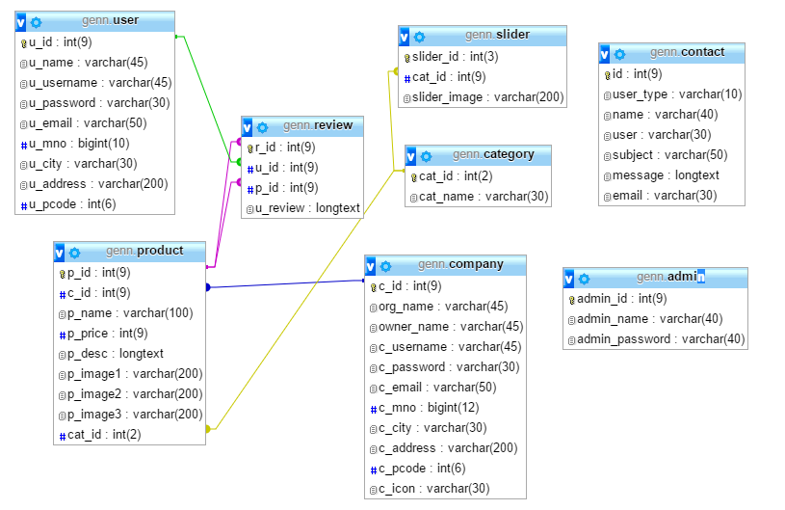

***TESTING***

* Unit Testing
* Integration Testing
* White Box Testing
* System Testing
* Environment Testing

**TESTING**

Once source code has been generated, software must be tested to uncover as many errors as possible before delivery to the client. Which is a very important to work the system successfully and achieve high quality of software. Testing includes designing a series of test cases that have a high likelihood of finding errors by applying software-testing techniques.

Software testing is a critical component of the software engineering process. It is an element of software quality assurance (SQA).

System testing makes logical assumptions that if all the parts of the system are correct, the goal will be successfully achieved. The system should be checked logically. Validations and cross checks should be there. Avoid duplication of records that cause redundancy of data.

This system is tested by the following steps and prepared for the final implementation.

* **Reviews**

Using review at different stages we ensured that

* Errors in function, logic or implementation are uncovered.
* Software meets its requirements.
* To achieve software that is developed in a uniform manner.

**UNIT TESTING**

In the web based application smallest testable unit is Web page itself. So the web pages of the site are to be unit tested. Each web page contains content, navigational links, and processing elements (scripts, event handlers, etc.) .The testing will be driven by the content processing, and links contained in the site.

Using black box testing technique web pages are tested unit by unit for whether they receive Input properly and give output in proper format or redirect to specific web page. It is also tested that the error message are properly displayed and give user-friendly information.

* **Guest Site**

|  |  |
| --- | --- |
| **Working Task** | **Result** |
| **1. Home Page** |  |
| * Working of login panel | Fine |
| * Classifieds Display | Fine |
| * Navigation Link | Fine |
| **2. Register Module** |  |
| * Fill the user registration detail | Fine |
| * Field validation | Fine |
| * Fill the advertiser registration detail | Fine |
| * Field validation | Fine |
| **3. Classifieds Display Module** |  |
| * Display different categories dynamically | Fine |
| * Display classifieds with detail | Fine |
| **4. Search Module** |  |
| * Verify searching criteria | Fine |
| * Display search result | Fine |
| * Display descriptive information | Fine |

* **User Site**

|  |  |
| --- | --- |
| **Working Task** | **Result** |
| **1. Home Page** |  |
| * Classifieds Display | Fine |
| * Navigation Link | Fine |
| **2. Classifieds Display Module** |  |
| * Display different categories dynamically | Fine |
| * Display classifieds with detail | Fine |
| * Send query for particular classified | Fine |
| **3. Search Module** |  |
| * Verify searching criteria | Fine |
| * Display search result | Fine |
| * Display descriptive information | Fine |
| **4. View Detail** |  |
| * View classifieds |  |
| * Display selected classifieds | Fine |
| * Display detailed information | Fine |
| * Send query for classified | Fine |
| * View inquiry response |  |
| * Display information according to read status | Fine |
| * View detail | Fine |
| * Send query for that response or delete that query detail | Fine |
| **5. Update Detail** |  |
| * Personal profile |  |
| * Field validation | Fine |
| * Change password |  |
| * Field validation | Fine |

* **Company Site**

|  |  |
| --- | --- |
| **Working Task** | **Result** |
| **1. Upload Classified Module** |  |
| * Select display format and display detail | Fine |
| * Display classified display preview | Fine |
| * Validate selection of field & display format | Fine |
| * Upload classified contents |  |
| * Field validation | Fine |

|  |  |
| --- | --- |
| **2. View Detail** |  |
| * View inquiry box |  |
| * Display information according to read status | Fine |
| * View detail | Fine |
| * Send response for that query or delete that response detail | Fine |
| **3. Update Detail** |  |
| * Personal profile |  |
| * Field validation | Fine |
| * Change password |  |
| * Field validation | Fine |
| **4. My Account Module** |  |
| * Account Detail |  |
| -Uploaded classified | Fine |
| -Delete classified | Fine |

* **Admin Site:**

|  |  |
| --- | --- |
| **Working Task** | **Result** |
| **1. Home Page** |  |
| * Navigation Link | Fine |
| **2. Slider Module** |  |
| * Verify slider | Fine |
| * Add Slider | Fine |
| * Delete Slider | Fine |
| **3. Category Module** |  |
| * Add Category | Fine |
| * Delete Category | Fine |
| * Validate field | Fine |
| **6. View Detail** |  |
| * Register user information | Fine |
| * Register company information | Fine |
| * Feedback information | Fine |
| * Advertiser information | Fine |
| * Personal detail | Fine |
| * Classified detail | Fine |

**WHITE BOX**

**TESTING**

White box testing is testing case design method that uses the control structure of the procedural design test cases. Using white box testing methods, one can devices test cases that –

* Grantees that all independent paths within a module have been exercised at least once.
* Exercise all logical decision on their true and false sides.
* Exercise all loops at their boundaries and within their operation

bounds.

* Exercises internal data structure to ensure their validity.

**INTEGRATION**

**TESTING**

We have used top down testing strategy for integrating web pages. The separately generated web pages will be integrated and for checking that they work properly after their integration, tests will be conducted to ensure their proper functionality.

Using dummy web pages it is checked that whether output of page will redirect to specific web page

After that regression testing strategy help us to ensure that changes do not introduce unintended behavior or additional errors.

**SYSTEM TESTING**

The uncovered weaknesses that were not found in earlier tests are removed in system testing. The system is corrected such away that it does not affect the forced system failure. This testing is done with low volume of transaction based on live data. Finally the total system is also tested to ensure that no data are lost.

Following testing on the completed system will be performed in order to find the errors before they become defects and correct them.

* In order to eliminate navigational errors the site will be reviewed and tested. The use cases scenarios that we have developed in the same document while requirement analysis activity will be considered to uncover errors in the navigational links.
* Web pages of the site will be unit tested. For the web pages sometimes the smallest testable unit is the single web page itself. Each web page contains content, navigational links, and processing elements (scripts, event handlers, etc.) .The testing will be driven by the content processing, and links contained in the site.
* The separately generated web pages will be integrated and for checking that they work properly after their integration, tests will be conducted to ensure their proper functionality.
* The functionality of the site will be checked with the different versions of the Internet Explorer, Netscape Navigator, etc. and wherever necessary it will be attempted to change the implementation of the not working for some browsers fir some case and of course without losing the purpose of the functionality, if possible.

**Environment**

**Testing**

* Following OS are considered for testing environment operability of software.
  + Windows XP
  + Windows 7/8/10
* Following Browsers are checked for operability of software.
  + Internet Explorer 5.5 or later
  + Mozilla Firefox
  + Google Chrome

**SCREEN SHOTS**

* **Home**

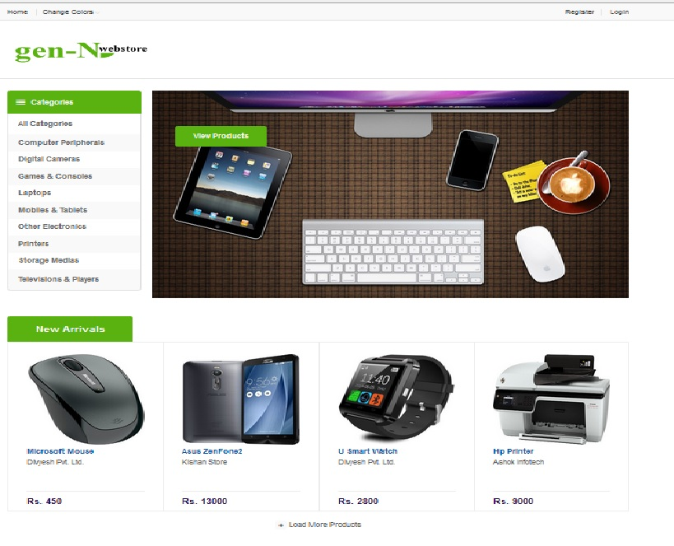

* **Login**

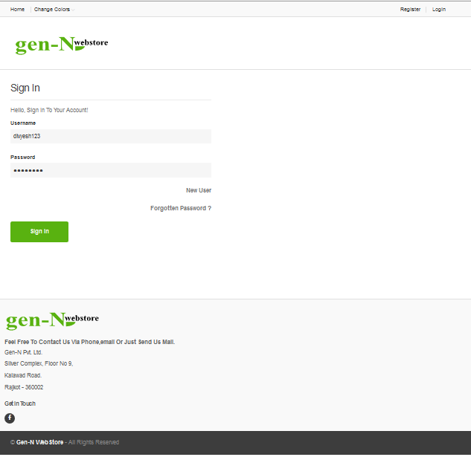

* **Registration**

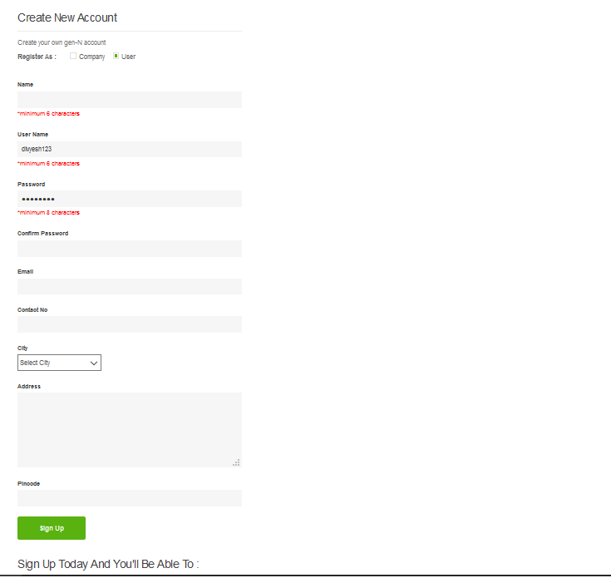

* **All Products**

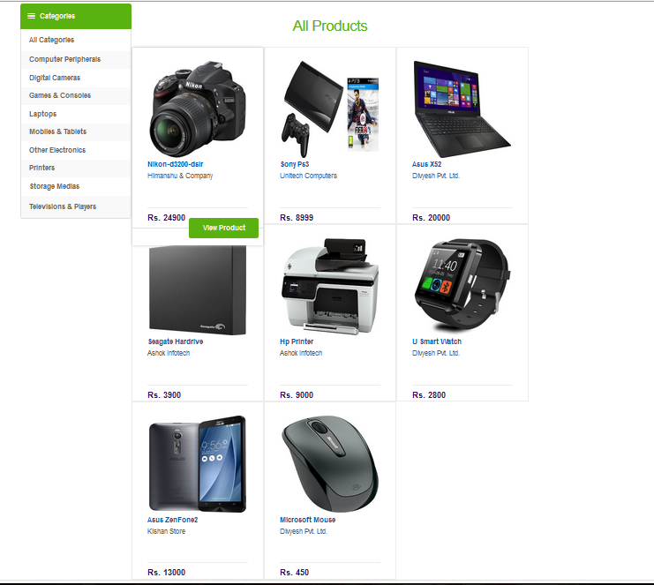

* **Profile**

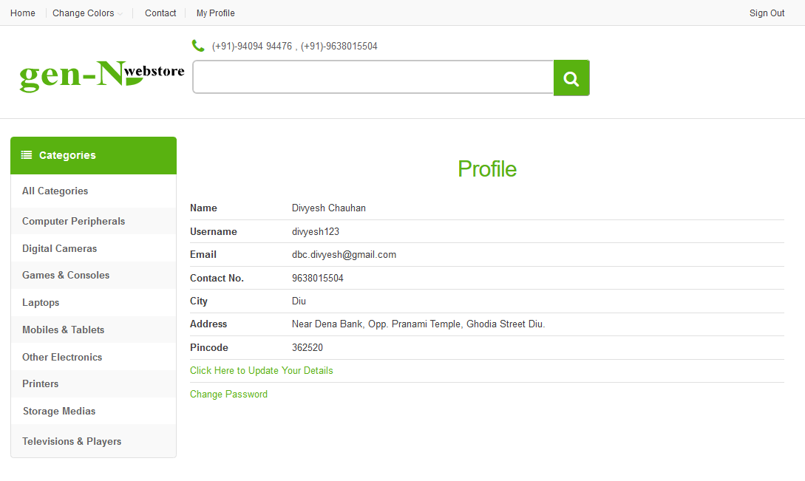

* **Contact**

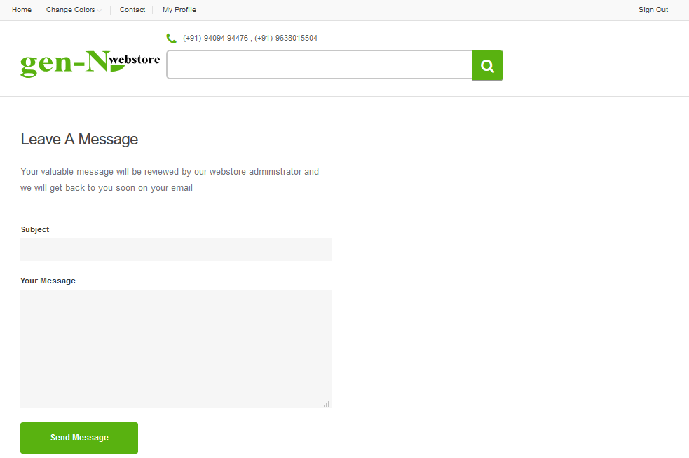

* **Change Password**

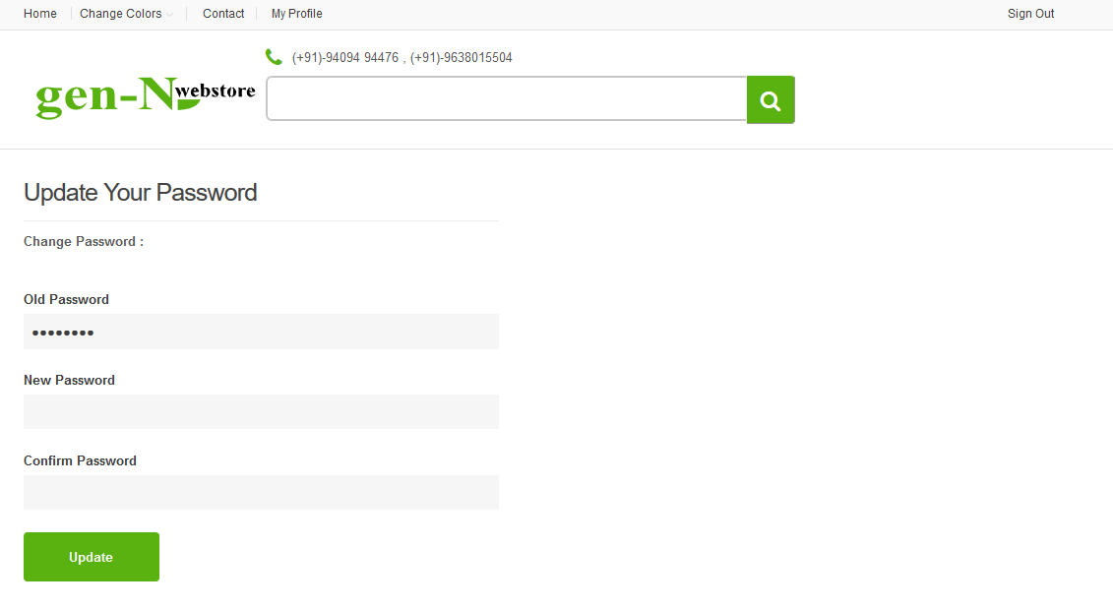

* **Reset Password**

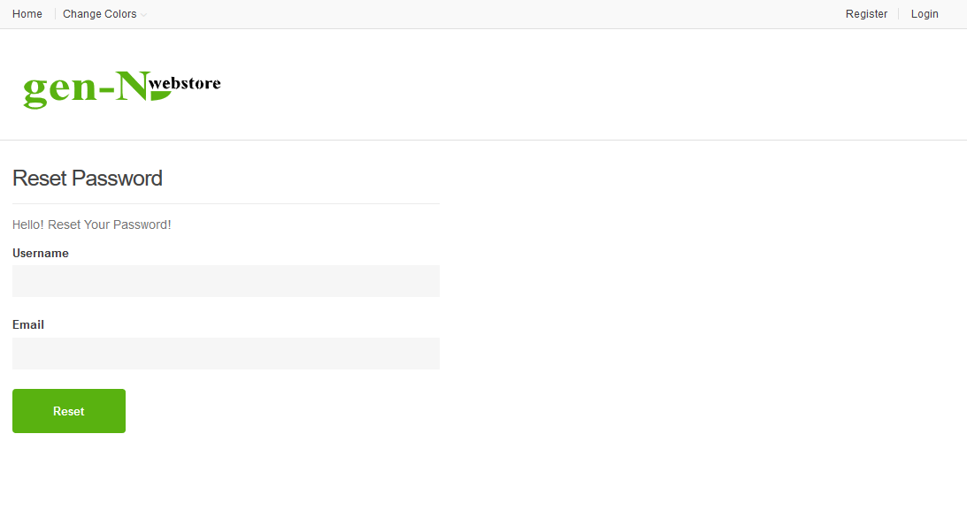

**Company Products**

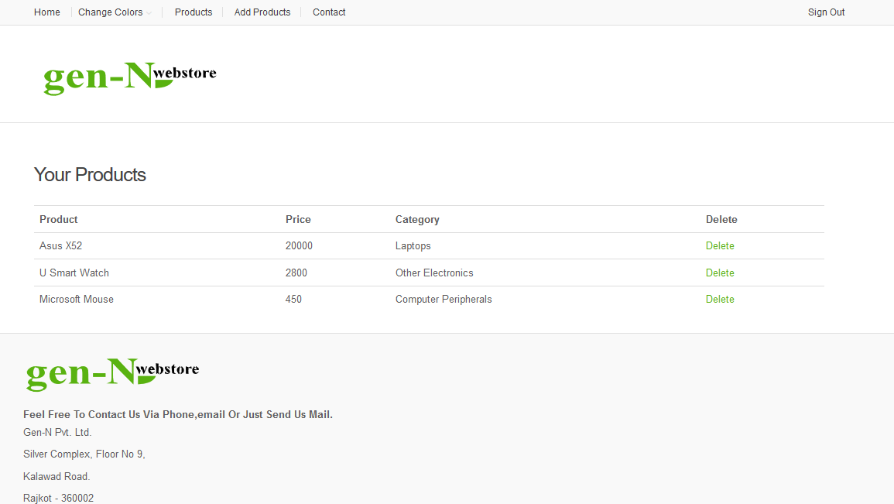

* **Adding Product**

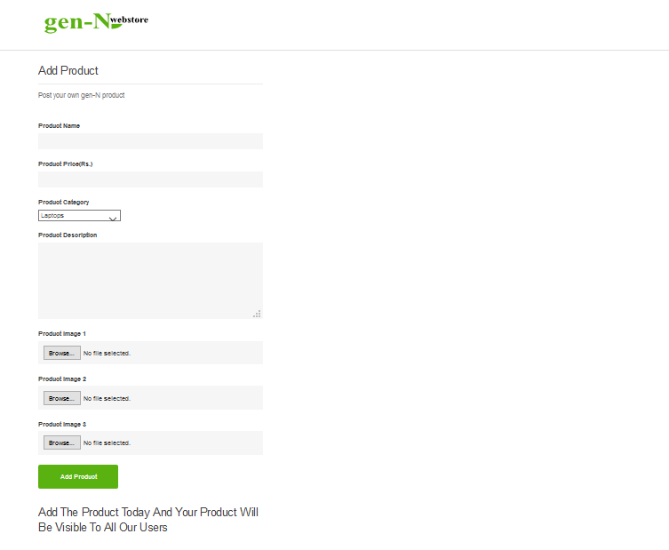

* **Admin’s User Management**

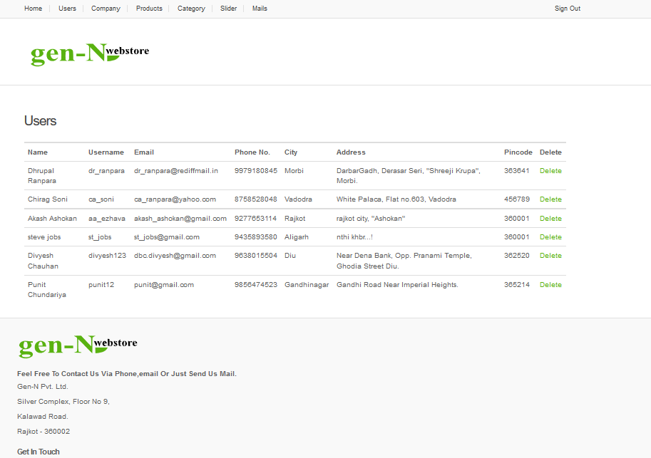

* **Admin’s Company Management**

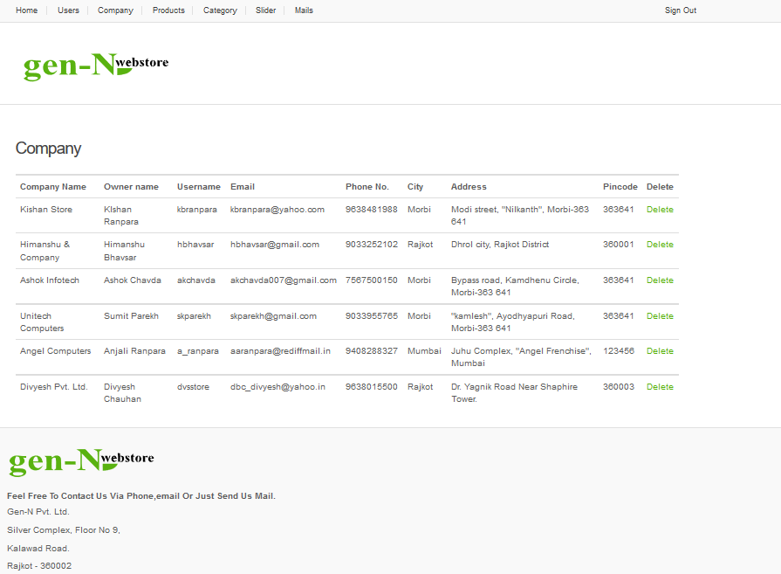

* **Admin’s Product Management**

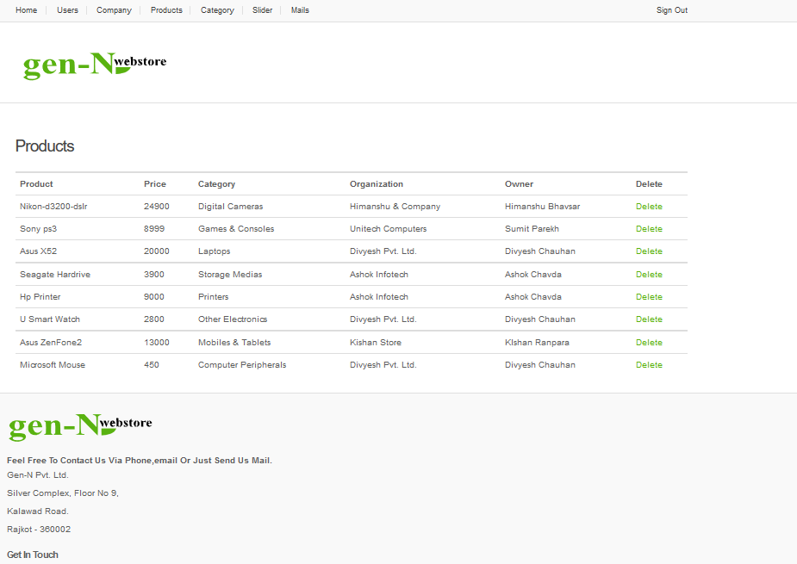

* **Admin’s Category Management**

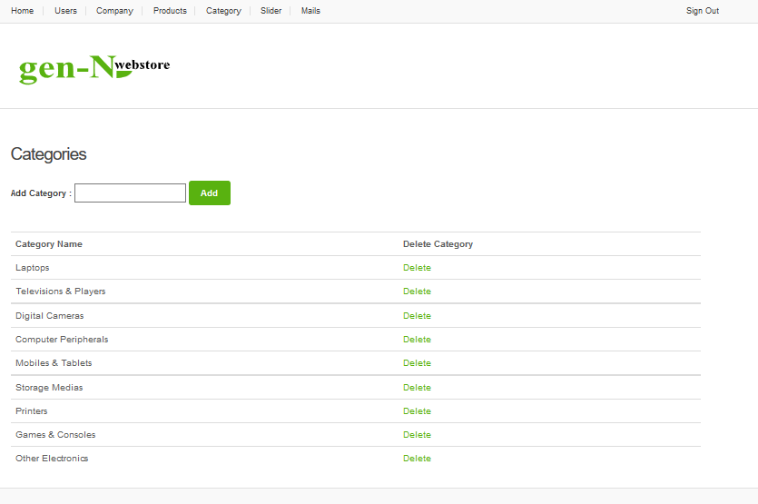

* **Admin’s Slider Management**

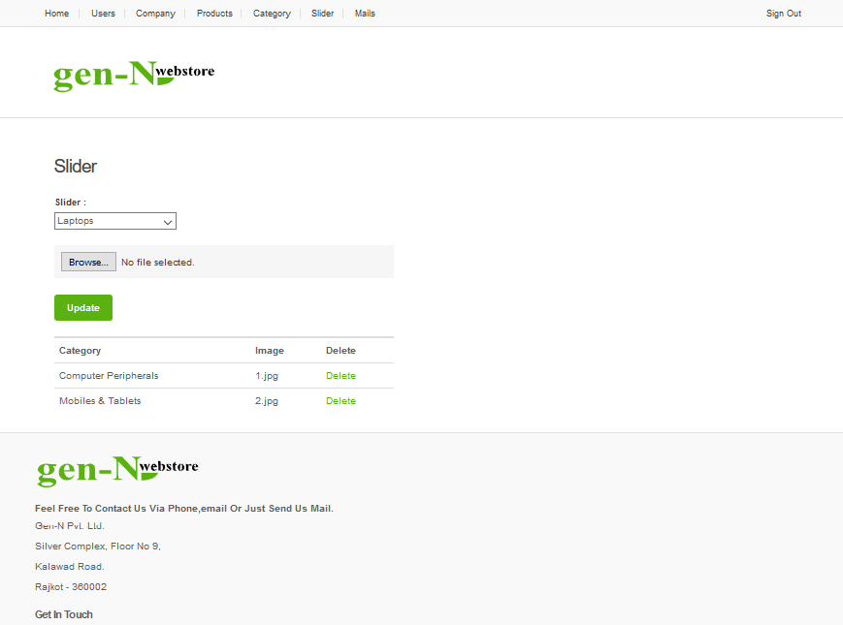

* **Admin’s Mail Management**

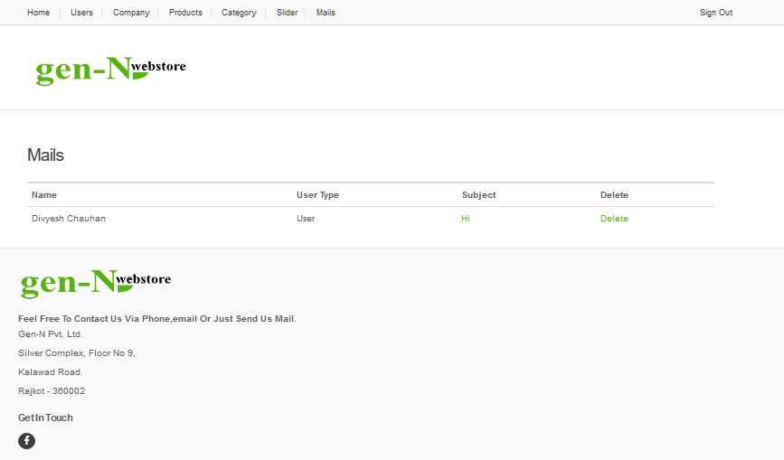

**SOURCE CODE**

**Index**

<?php

session_start();

include_once("connect.php");

$rs=mysql_query("select * from slider");

?>

<!DOCTYPE html>

<html lang="en">

<body>

<?php

if(isset($_SESSION['aid']))

{

echo "<script>window.location='admin/adminhome.php';</script>";

}

if(isset($_SESSION['uid']))

{

include_once("include/userh.php");

}

else

{

include_once("include/visitorh.php");

}

?>

<div class="wrapper">

<div id="top-banner-and-menu">

<div class="container">

<?php

include_once("include/categories.php");

?>

<div class="col-xs-12 col-sm-8 col-md-9 homebanner-holder">

<div id="hero">

<div id="owl-main" class="owl-carousel owl-inner-nav owl-ui-sm">

<?php while($v=mysql_fetch_array($rs))

{

echo "<div class='item' style=' background-image: url(assets/images/sliders/".$v['slider_image'].")';>

<div class='container-fluid'>

<div class='caption vertical-center text-left'>

<div class=button-holder fadeInDown-3>

<a href='categoryview.php?ci=".$v['cat_id']."' class='big le-button'>View Products</a>

</div>

</div>

</div>

</div>";

}

?>

</div><!-- /.owl-carousel -->

</div>

</div><!-- /.homebanner-holder -->

</div><!-- /.container -->

</div><!-- /# top-banner-and-menu -->

</div><!-- /.wrapper -->

</div><!-- /.wrapper -->

<?php include_once("include/newarrival.php"); ?>

<?php include_once("include/footer.php") ?>

**Sign In**

<?php

session_start();

include_once("connect.php");

if(isset($_SESSION['uid']))

{

echo "<script>window.location='index.php';</script>";

}

?>

<!DOCTYPE html>

<html lang="en">

<body>

<div class="wrapper">

<?php

include_once("include/visitorh.php");

if(isset($_POST['login']))

{

$u=$_POST['txtuname'];

$p=$_POST['txtpwd'];

$rs=mysql_query("select * from user where u_username='$u' and u_password='$p'");

$v=mysql_fetch_array($rs);

$rsc=mysql_query("select * from company where c_username='$u' and c_password='$p'");

$va=mysql_fetch_array($rsc);

$rsa=mysql_query("select * from admin where admin_name='$u' and admin_password='$p'");

$vaa=mysql_fetch_array($rsa);

if(mysql_num_rows($rs)>0)

{

$_SESSION['uid']=$v['u_id'];

$_SESSION['uname']=$v['u_name'];

if(isset($_GET['ci']))

{

echo "<script>window.location='categoryview.php?ci=".$_GET['ci']."'</script>";

}

else if(isset($_GET['pid']))

{

echo "<script>window.location='productdetails.php?pid=".$_GET['pid']."'</script>";

}

else if(isset($_GET['p']))

{

echo "<script>window.location='products.php'</script>";

}

else

{

echo "<script>window.location='index.php'</script>";

}

}

else if(mysql_num_rows($rsc)>0)

{

$_SESSION['cid']=$va['c_id'];

$_SESSION['cname']=$va['org_name'];

$_SESSION['oname']=$va['owner_name'];

echo "<script>window.location='companydetails.php'</script>";

}

else if(mysql_num_rows($rsa)>0)

{

$_SESSION['aid']=$vaa['admin_id'];

$_SESSION['aname']=$vaa['admin_name'];

echo "<script>window.location='admin/adminhome.php';</script>";

}

else

{

echo "<script>window.location='signin.php?err=1';</script>";

}

}

?>

<main id="authentication" class="inner-bottom-md">

<div class="container">

<div class="row">

<div class="col-md-6">

<section class="section sign-in inner-right-xs">

<h2 class="bordered">Sign In</h2>

<p>Hello, Sign In To Your Account!</p>

<form role="form" class="login-form cf-style-1" method="post" name="login">

<div class="field-row">

<label>Username</label>

<input type="text" class="le-input" name="txtuname">

</div><!-- /.field-row -->

<div class="field-row">

<label>Password</label>

<input type="password" class="le-input" name="txtpwd">

</div><!-- /.field-row -->

<div class="field-row clearfix">

<span class="pull-right">

<a href="signup.php" class="content-color bold">New User</a>

</span>

</div>

<div class="field-row clearfix">

<span class="pull-right">

<a href="forgotpassword.php" class="content-color bold">Forgotten Password ?</a>

</span>

</div>

<div class="buttons-holder">

<button type="submit" class="le-button huge" name="login">Sign In</button><br><br>

<?php

if(isset($_GET['err']))

{

echo "<table style='color:#FF0000'><tr><td>Sorry, You have entered incorrect username/password !</td></tr></table>";

}

?>

</div><!-- /.buttons-holder -->

</form><!-- /.cf-style-1 -->

</section><!-- /.sign-in -->

</div>

</div><!-- /.row -->

</div><!-- /.container -->

</main><!-- /.authentication -->

<?php include_once('include/footer.php'); ?>

<script type="text/javascript" src="assets/js/valid.js"></script>

<script src="switchstylesheet/switchstylesheet.js"></script>

</body>

</html>

**Registration**

<?php

session_start();

if(isset($_SESSION['uid']))

{

echo "<script>window.location='index.php';</script>";

}

include_once("connect.php");

if(isset($_POST['reguser']))

{

$u=$_POST['uname'];

$rs=mysql_query("select * from user where u_username='$u'");

$rsc=mysql_query("select * from company where c_username='$u'");

$rsa=mysql_query("select * from admin where admin_name='$u'");

if(mysql_num_rows($rs)>0 || mysql_num_rows($rsc)>0 || mysql_num_rows($rsa)>0)

{

echo "<script>

alert('Username already exist!\\nPlease Change it.');

document.userform.uname.focus();

</script>";

}

else

{

$q="insert into user(u_name,u_username,u_password,u_email,u_mno,u_city,u_address,u_pcode) values('".$_POST['name']."','".$_POST['uname']."','".$_POST['password']."','".$_POST['email']."',".$_POST['contact'].",'".$_POST['city']."','".$_POST['address']."',".$_POST['pincode'].")";

if(mysql_query($q))

{

echo "<script>

alert('Congratulations !, Your account is created Successfully.\\nClick ok to login');

window.location='signin.php';

</script>";

}

}

}

if(isset($_POST['regcompany']))

{

$u=$_POST['cuname'];

$rs=mysql_query("select * from user where u_username='$u'");

$rsc=mysql_query("select * from company where c_username='$u'");

if(mysql_num_rows($rs)>0 || mysql_num_rows($rsc)>0)

{

echo "<script>

alert('Username already exist...Please Change it.');

document.userform.uname.focus();

</script>";

}

else

{

$q="insert into company(org_name,owner_name,c_username,c_password,c_email,c_mno,c_city,c_address,c_pcode,c_icon) values('".$_POST['cname']."','".$_POST['oname']."','".$_POST['cuname']."','".$_POST['cpassword']."','".$_POST['cemail']."',".$_POST['ccontact'].",'".$_POST['ccity']."','".$_POST['caddress']."',".$_POST['cpincode'].",'".$_FILES['clogo']['name']."')";

if(mysql_query($q))

{

echo "<script>

alert('Congratulations !, Your account is created Successfully.\\nClick ok to login');

window.location='signin.php';

</script>";

}

}

}

?>

<!DOCTYPE html>

<html lang="en">

<head>

</head>

<body>

<div class="wrapper">

<?php

include_once("include/visitorh.php");

?>

<main id="authentication" class="inner-bottom-md">

<div class="container">

<div class="row">

<!-- /.col -->

<div class="col-md-6" >

<section class="section sign-in inner-right-xs">

<h2 class="bordered">Create New Account</h2>

<p>Create your own gen-N account</p>

<label>Register As : </label>

&nbsp; &nbsp;&nbsp; &nbsp;

<input type="radio" name="regas" id="co" class="le-radio" value="commpany" onClick="checkType('block','none');">Company &nbsp; &nbsp;

<input type="radio" checked="checked" name="regas" id="us" class="le-radio" value="user" onClick="checkType('none','block');">User

<form role="form" class="register-form cf-style-1" name="compform" id="comform" style="display:none" method="post" enctype="multipart/form-data" onSubmit="return chkCompForm();"> <!-- /.field-row -->

<div class="field-row">

<label>Comapny Name</label>

<input type="text" class="le-input" name="cname">

<p>*minimum 6 characters</p>

</div><!-- /.field-row -->

<div class="field-row">

<label>Owner Name</label>

<input type="text" class="le-input" name="oname">

<p>*minimum 6 characters</p>

</div>

<div class="field-row">

<label>Username</label>

<input type="text" class="le-input" name="cuname">

<p>*minimum 6 characters</p>

</div>

<div class="field-row">

<label>Password</label>

<input type="password" class="le-input" name="cpassword">

<p>*minimum 8 characters</p>

</div>

<div class="field-row">

<label>Confirm Password</label>

<input type="password" class="le-input" name="ccnpassword">

</div>

<div class="field-row">

<label>Email</label>

<input type="text" class="le-input" name="cemail">

</div>

<div class="field-row">

<label>Contact No.</label>

<input type="text" class="le-input" maxlength="10" name="ccontact">

</div>

<div class="field-row">

<label>City</label>

<select name="ccity">

<option value="default" label="Select City" selected class="le-select">Select City</option>';

</select>

</div>

<div class="field-row">

<label>Address</label>

<textarea class="le-input" rows="6" name="caddress"></textarea>

</div>

<div class="field-row">

<label>Pincode</label>

<input type="text" class="le-input" maxlength="6" name="cpincode">

</div>

<div class="buttons-holder">

<button type="submit" class="le-button huge" name="regcompany">Sign Up</button>

</div><!-- /.buttons-holder -->

</form>

<form role="form" class="register-form cf-style-1" name="userform" id="userform" method="post" onSubmit="return chkUserForm();">

<div class="field-row">

<label>Name</label>

<input type="text" class="le-input" name="name">

<p>*minimum 6 characters</p>

</div><!-- /.field-row -->

<div class="field-row">

<label>User Name</label>

<input type="text" class="le-input" name="uname">

<p>*minimum 6 characters</p>

</div>

<div class="field-row">

<label>Password</label>

<input type="password" class="le-input" name="password">

<p>*minimum 8 characters</p>

</div>

<div class="field-row">

<label>Confirm Password</label>

<input type="password" class="le-input" name="cnpassword">

</div>

<div class="field-row">

<label>Email</label>

<input type="text" class="le-input" name="email">

</div>

<div class="field-row">

<label>Contact No</label>

<input type="text" class="le-input" name="contact" maxlength="10">

</div>

<div class="field-row">

<label>City</label>

<select name="city">

<option value="default" label="Select City" selected class="le-select">Select City</option>';

</select>

</div>

<div class="field-row">

<label>Address</label>

<textarea class="le-input" rows="6" name="address"></textarea>

</div>

<div class="field-row">

<label>Pincode</label>

<input type="text" class="le-input" maxlength="6" name="pincode">

</div>

<div class="buttons-holder">

<button type="submit" class="le-button huge" name="reguser" >Sign Up</button>

</div><!-- /.buttons-holder -->

</form>

<h2 class="semi-bold">Sign up today and you'll be able to :</h2>

<ul class="list-unstyled list-benefits">

<li><i class="fa fa-check primary-color"></i> Post your Adds for free</li>

<li><i class="fa fa-check primary-color"></i> Sell your products easily</li>

<li><i class="fa fa-check primary-color"></i> Keep a record of all your Adds</li>

</ul>

</section><!-- /.register -->

</div><!-- /.col -->

</div><!-- /.row -->

</div><!-- /.container -->

</main><!-- /.authentication -->

<?php

include_once('include/footer.php');

?>

<script type="text/javascript" src="assets/js/valid.js"></script>

</body>

</html>

**Add Products**

<?php

session_start();

if(!isset($_SESSION['cid']))

{

echo "<script>window.location='index.php';</script>";

}

include_once("connect.php");

if(isset($_POST['addproduct']))

{

$c=$_SESSION['cid'];

$ct=$_POST['pcat'];

$rs=mysql_query("select * from category where cat_name='$ct'");

$b=mysql_fetch_array($rs);

$cat=$b['cat_id'];

if(move_uploaded_file($_FILES['pimg1']['tmp_name'],"assets/images/products/".$_FILES['pimg1']['name']) &&

move_uploaded_file($_FILES['pimg2']['tmp_name'],"assets/images/products/".$_FILES['pimg2']['name']) &&

move_uploaded_file($_FILES['pimg3']['tmp_name'],"assets/images/products/".$_FILES['pimg3']['name']))

{

$q="insert into product(c_id,p_name,p_price,p_desc,p_image1,p_image2,p_image3,cat_id) values($c,'".$_POST['pname']."',".$_POST['pprice'].",'".$_POST['pdesc']."','".$_FILES['pimg1']['name']."','".$_FILES['pimg2']['name']."','".$_FILES['pimg3']['name']."',$cat)";

if(mysql_query($q))

{

echo "<script>

alert('Congratulations ! \\nYour product was added Successfully.');

</script>";

}

}

else

{

echo "<script>

alert('Image');

</script>";

}

}

?>

<!DOCTYPE html>

<html lang="en">

<body>

<div class="wrapper">

<?php

include_once("include/companyh.php");

?>

<main id="authentication" class="inner-bottom-md">

<div class="container">

<div class="row">

<!-- /.col -->

<div class="col-md-6" >

<section class="section sign-in inner-right-xs">

<h2 class="bordered">Add Product</h2>

<p>Post your own gen-N product</p>

<form role="form" class="register-form cf-style-1" name="add" id="comform" method="post" enctype="multipart/form-data" onSubmit="return chkProduct();"> <!-- /.field-row -->

<div class="field-row">

<label>Product Name</label>

<input type="text" class="le-input" name="pname">

</div><!-- /.field-row -->

<div class="field-row">

<label>Product Price(Rs.)</label>

<input type="text" class="le-input" name="pprice" onKeyPress="validNumber();">

</div>

<div class="field-row">

<label>Product Category</label>

<select name="pcat">

<?php

$rsc=mysql_query("select * from category");

while($v=mysql_fetch_array($rsc))

{

echo "<option id=".$v['cat_id']."value=".$v['cat_id'].">".$v['cat_name']."</option>";

}

?>

</select>

</div>

<div class="field-row">

<label>Product Description</label>

<textarea class="le-input" rows="6" name="pdesc"></textarea>

</div>

<div class="field-row">

<label>Product Image 1</label>

<input type="file" class="le-input" name="pimg1" >

</div>

<div class="field-row">

<label>Product Image 2</label>

<input type="file" class="le-input" name="pimg2" >

</div>

<div class="field-row">

<label>Product Image 3</label>

<input type="file" class="le-input" name="pimg3" >

</div>

<div class="buttons-holder">

<button type="submit" class="le-button huge" name="addproduct">Add Product</button>

</div><!-- /.buttons-holder -->

</form>

<h2 class="semi-bold">Add the product today and your product will be visible to all our users</h2>

</section><!-- /.register -->

</div><!-- /.col -->

</div><!-- /.row -->

</div><!-- /.container -->

</div>

</main><!-- /.authentication -->

<?php

include_once('include/footer.php');

?>

<script type="text/javascript" src="assets/js/valid.js"></script>

</body>

</html>

**CONCLUSION**

* **Drawbacks**

Once the classified is added it can not be modified it can only be deleted.

User can not sort the classified based on the company or price list.

User and companies cannot interact directly.

* **Future Plans**

We would like to implement the facility that user and companies can interact directly.

We would also like to implement the facility of instant messaging.

Advanced sorting facility and subcategories can be added to our system

**BIBLIOGRAPHY**

To develop this project I have taken help of following Books:

* + PHP Bible
  + Beginning PHP5
  + Pure JavaScript

To develop this project I have taken help of following Websites:

* www.w3schools.com
* www.google.com